**Hackathon 2022, Organised by DA-IICT**

**Team Name: UNKILS**

**Team Members:**

**Vishwas Bheda**

**Akshit Kachhadiya**

**Indrajeet Khatri**

**Mukesh Sahu**

Yesterday, we deeply studied the idea of our team, came out with new solutions and made some changes.

Today we Discussed the codes included in our project and programmed accordingly, also we started working on frontend of our website, half of the team was working on backend and the other half was working on design of the website.

This can be useful in security reasons, also main focus on the blind children and trying to make the education simple.

We created the rough design of website as follows-

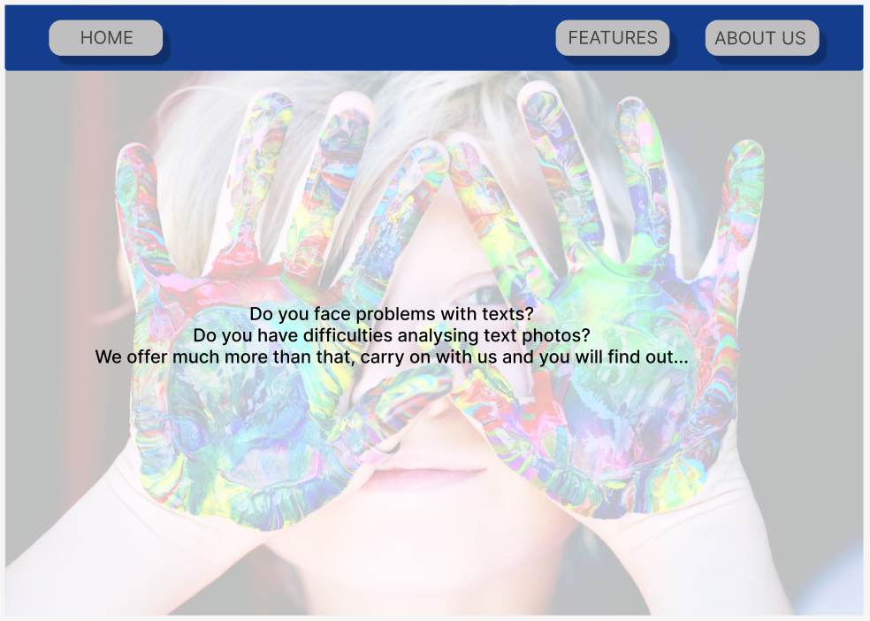

The landing page is left to modify as we had to work on the further pages of website.

The next page given below starts showing the features of our website and the page below particularly gives options to the user to insert the image or speech.

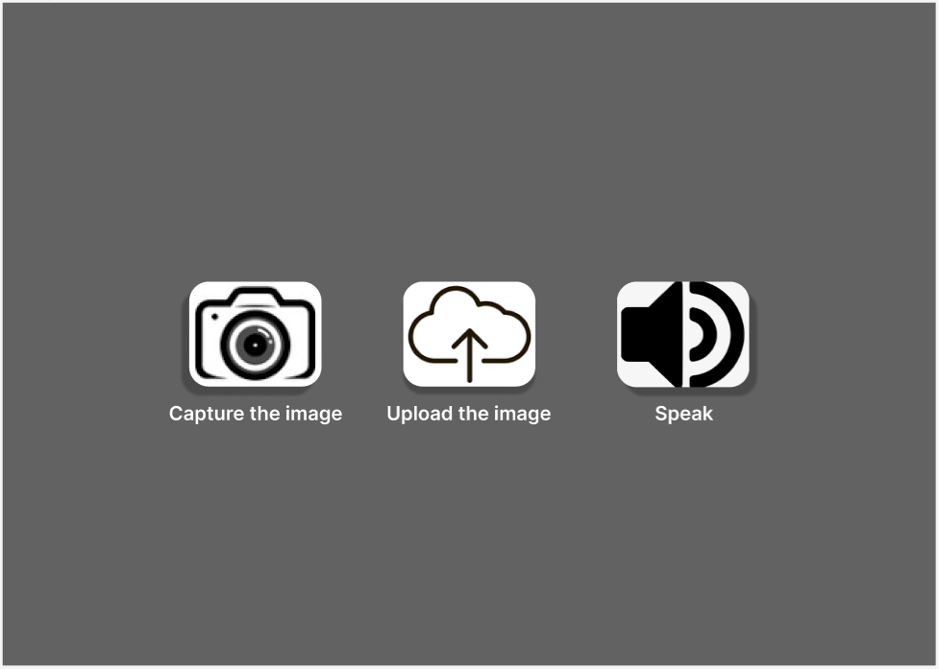

* First button directly captures the image which user is trying to examine.
* Second button uploads image from the device
* Third button takes the input from the user in the form of speech and converts it into text.

In Third page, the user gets to decide which operation should be carried out as per their will.

The page contains of 3 choices and they are –

* Speech of desired language, where the input is converted into the speech output of selected language.
* Output in Braille
* Output in Morse

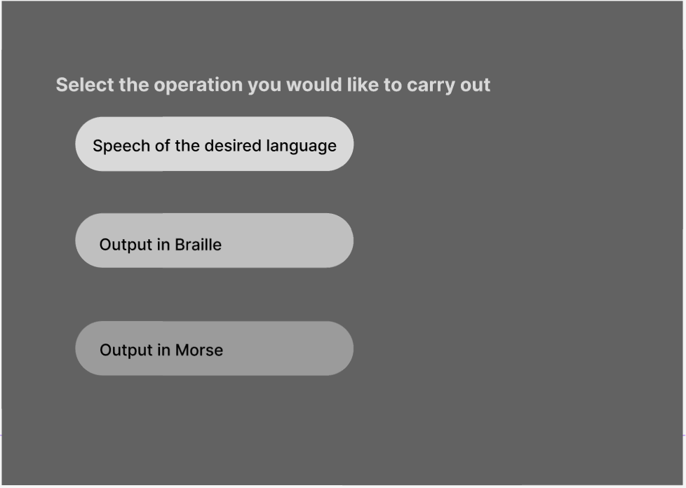

The 4th page shows the result page of “Speech of the desired language.

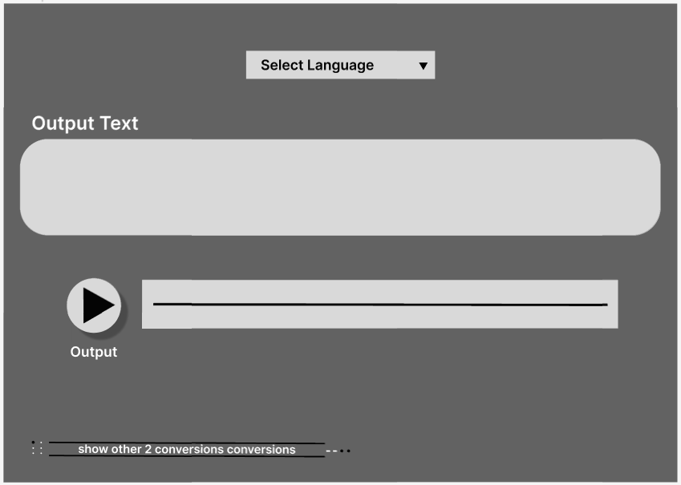

The 5th page shows the result page of “Output in Braille”.

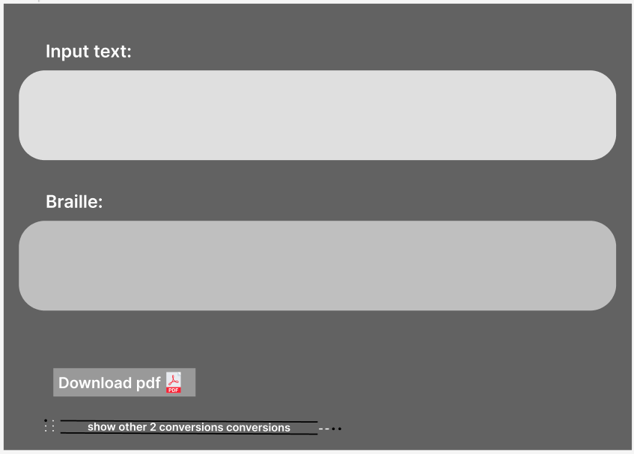

The 6th page shows “Output in Morse”.

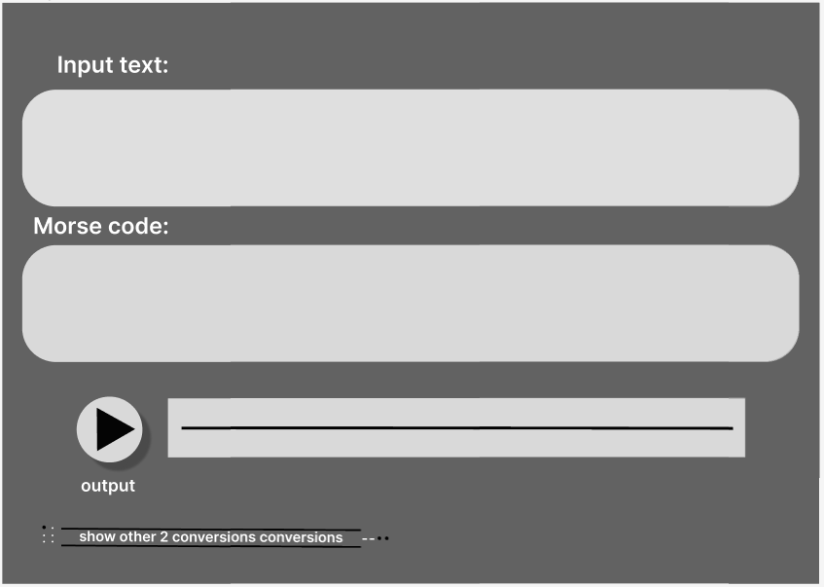

This is where you can refer the codes for the website.

<https://github.com/Aksh0404/Hackout-22-Unkils.git>